Directions: Answer the following questions while viewing the video.
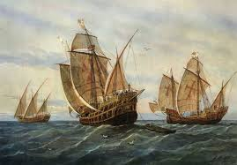
1) What are the names of Columbus’ ships?

2) What was the purpose of Christopher Columbus’ voyage?

3) What goods were being sold through the Silk Road?

4) What were some of the reasons (or innovations) that allowed Europe’s population to reach over 100 million people?

5) What is the name of great city, built by the mound builders? What is known about them?

6) What staple crop, developed by genetic engineering, helped the mound builders to prosper?

7) What crop helped the Inca to proper without corn, as it would not grow in the high altitudes?

8) How were they able to grow this crop? (How did they alter the landscape?)

9) What is the biggest domestic mammal in the Americas, before Columbus?

10) Why were there no domesticated animals in North America?

11) What is the most important animal to the Native Americans?
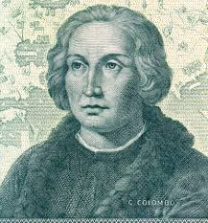

12) How did the Native Americans hunt these animals?

13) How was hunting different for the Europeans?

14) What happened to the fish stocks in Europe?

15) How is fishing different in the Americas?

16) Why did the Anasazi, the civilization located in present day New Mexico, disappear?

17) How was wood important to the Europeans? (What were they using wood for?)

18) What object was invented that allowed the spread of new ideas and information?

