Connections and Summary | Chapter 3 Section 1 Migration
1. Vocabulary: (4 terms)  2. Images: (2 images )  3. Significant: (4 Points that are significant to highlight from the notes)  4. Explain Zelinsky’s theory of migration.  5. Question: What are some real life examples of push and pull factors? (Political, Cultural, Environmental, Economic) | Migration  - A permanent move to a new location constitutes migration.  - Migration is a specific type of relocation diffusion and a form of Mobility. Mobility is movement from one place to another.  - Circulation is a form of Mobility, it refers to the short term repetitive or cyclical movements that recur on a regular basis. Daily, monthly or annually.  Migration  –Emigration is migration from a location.  –Immigration is migration to a location.  Place “A” can have individuals migrating away from and to it.  Emigrant: Place A → Place B  Immigrant: Place B → Place A  Ex: Moving from the US to Mexico is considered Emigration. While moving from Mexico to the US is considered immigration  - Difference between the number of immigrants and the number of emigrants is a place’s net migration.  - If a country has a high net migration rate it is seen as wealthy and developed. In contrast, a country with a low rate is seen as undeveloped.  Formula for calculating Net Migration  •N = (I - E) / M X 1,000  •N = Net Migration Rate  •I = Number of Immigrants Entering the Area  •E = Number of Emigrants Leaving the Area  •M = Mid Year Population  Why are Geographers interested in migration?  1. Produces profound changes for individuals and cultures.  2. Permanent moves to a new location disrupts traditional cultural ties.  3. Disrupts economic patterns  4. Diffusion of culture; language, religion, ethnicity etc.  Migration Theory  E. G. Ravenstein outlined the laws of Migration, which explain  - The reasons why migrants move  - The distance they typically move  - Their characteristics  - *We will explore these in small groups later.  Why Migrate?  - Desperate Conditions  - Most people migrate in search of three objectives: Economic opportunity, cultural, freedom, and environmental comfort.  Wilbur Zelinsky  •Proposed that changes in society are comparable with those in the Demographic Transition Model  •Migration transition results from the social and economic changes that are produced in the demographic transition.  •Stage 1: Very little migration  •Stage 2: International migration  •Stage 3 and 4: Internal Migration  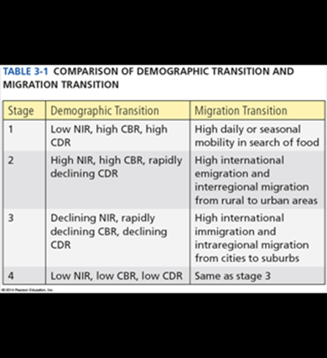
 | Summary:

