Connections and Summary | Why Do Boundaries Cause Problems?
1. Main Idea of Notes  2. Vocabulary: (4)  3. Significant Points: (4)  4. Sketch Examples: Provide examples of the 5 different types of shapes of states.  5. What is the difference between an autocratic and democratic government?  6. What are the three forms of gerrymandering? | Types of Boundaries  – A state is separated from its neighbors by a boundary, an invisible line the marks the extent of a state’s territory.  – Historically, frontiers, which is a zone where no state exercises complete political control, rather than boundaries separated states.  – Three types of physical elements serve as boundaries between states:  1. Desert Boundary – Effectively divide two states, because deserts are hard to cross and sparsely inhabited.  Ex: Desert Boundary – Mali and Mauritania: The unmarked border runs through the Sahara Desert  2. Mountain Boundary – Effectively divide two states, if the mountains are difficult to cross.– Useful boundaries because of their permanent quality and their tendency to be sparsely populated.  3. Water Boundary – Examples include rivers, lakes, and oceans.  – Less permanent overall than mountain boundaries because of tendencies of water levels to change in bodies of water and river channels to move over time.  Types of Boundaries  The Law of the Sea  -States that have ocean boundaries are able to claim vast areas of the ocean for defense and for control of fishing areas.  -The Law of the Sea Treaty is the international agreement that resulted from the 3rd UN Conference on the Sea, which took place between 1973 and 1982, and signed by 158 countries.  Types of Boundaries  Cultural Boundaries  • Geometric Boundaries – Straight lines drawn on a map.  – EX: 2,100-kilometer (1,300-mile) straight line along  49º north latitude that separates the U.S. and Canada.  » Boundary established in 1846 by a treaty between U.S. and Great Britain.  • Ethnic Boundaries  – Boundary coincides with differences in ethnicity, especially language and religion.  – Language differences influenced the demarcation of boundaries in England, France, Portugal, and Spain before the 19th century in Europe.  Shapes of States  – Controls the length of its boundaries with other states.  • Affects the potential for communication and conflict with neighbors.  – Shape is part of a country’s unique identity.  – Shape also influences the ease or difficulty of internal administration and can affect social unity.  Shapes of States  – Countries have one of five basic shapes  1. Compact States: Efficient  – Distance from center of state to any boundary does not vary significantly.  » Ideal theoretical example would be circle-shaped with the capital in the center.  2. Elongated States: EX: Chile: Potential Isolation  – Long and narrow shape.  – May suffer from poor internal communications.  – Example: Chile  » 4,000 km. (2,500 mi.) long north and south  » Rarely exceeds 150 km. (90 mi.) wide east and west.  Why Do Boundaries Cause Problems?  • Shapes of States  – Countries have one of five basic shapes  3. Prorupted States: Either gives access or disruption  – Otherwise compact state with a large projecting extension.  – Proruptions created for two principal reasons.  1. Provide a state with access to a resource, such as water.  2. Separate two states that other would share a boundary.  4. Perforated States: EX: South Africa  – A state that completely surrounds another one.  – Encompassed state is dependent on the surrounding state for  interactions beyond its boundary.  » E.G. Vatican City surrounded by Italy  Why Do Boundaries Cause Problems?  • Shapes of States  – Countries have one of five basic shapes  5. Fragmented States: Problematic  – A state that includes several discontinuous pieces of territory.  – Two kinds of fragmented states  1. Fragmented states separated by water  2. Fragmented states separated by an intervening state.  Examples of Shapes in Southern Africa  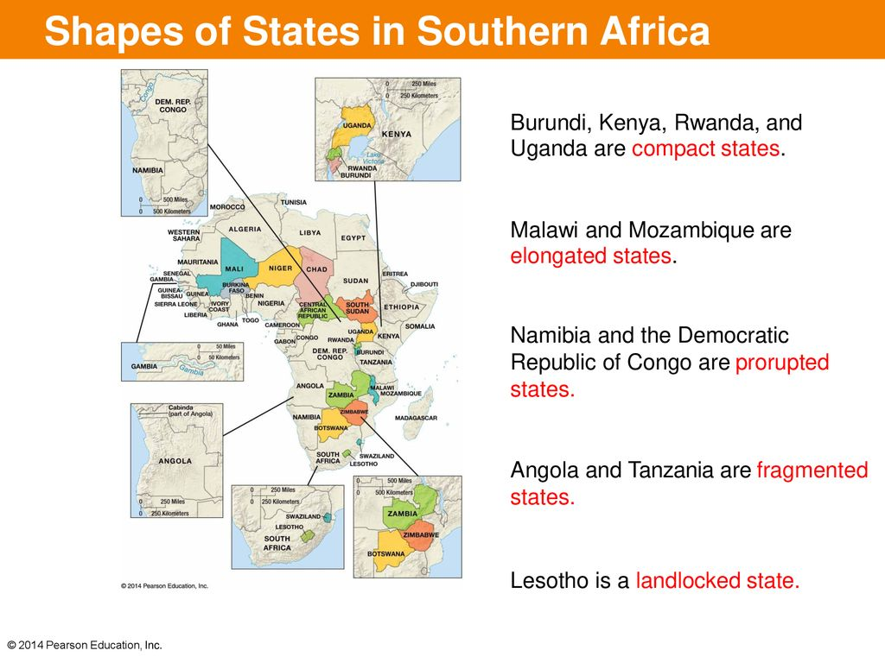  • Governing States  – National governments can be classified as democratic, autocratic, or anocratic.  • A democracy is a country in which citizens elect leaders and can run for office.  • An autocracy is a country that is run according to the interests of the ruler rather than the people.  • An anocracy is a country that is not fully democratic or fully autocratic, but rather a mix of the two.  – National Scale: Regime Types  • Democracies and autocracies differ in three essential elements:  1. Selection of Leaders  » Democracies have institutions and procedures through which citizens can express effective preferences about alternative policies and leaders.  » Autocracies have leaders who are selected according to clearly defined (usually hereditary) rules of succession from within the political elite.  2. Citizen Participation  » Democracies have institutionalized constraints on the exercise of power by the executive.  » Autocracies have citizen’s participation restricted or suppressed.  3. Checks and Balances:  » Democracies guarantee civil liberties to all citizens.  » Autocracies have leaders who exercise power with no meaningful checks from legislative, judicial, or civil society institutions.  – In general, the world has become more democratic since the turn of the 19th century.  • Approaches to the organization of government  – Unitary State  • Most power is placed in the central government:  – Japan  – Federal State  • Allocates power to units of local government  – The United States  – Confederation  • A union of states for common action – usually  defense, currency, or foreign affairs  – The EU or Switzerland  • Electoral Geography  – Boundaries separating legislative districts within the U.S. and other countries are redrawn periodically to ensure each has about the same population.  • 435 districts of the U.S. House of Representatives are redrawn every 10 years, following the Census Bureauʼs release of the official population figures.  – Process of redrawing legislative boundaries for the purpose of benefits the party in power is called gerrymandering.  • Electoral Geography  – Gerrymandering takes three forms:  1. Wasted vote spreads opposition supporters across many districts but in the minority.  2. Excess vote concentrates opposition supported into a few districts.  3. Stacked vote links distant areas of like-minded voters through oddly shaped boundaries.  – U.S. Supreme Court ruled gerrymandering illegal in 1985 but did not require dismantling of existing oddly shaped districts.
 | Summary:

